Name :Karthikeyan E

Reg No:73152115036

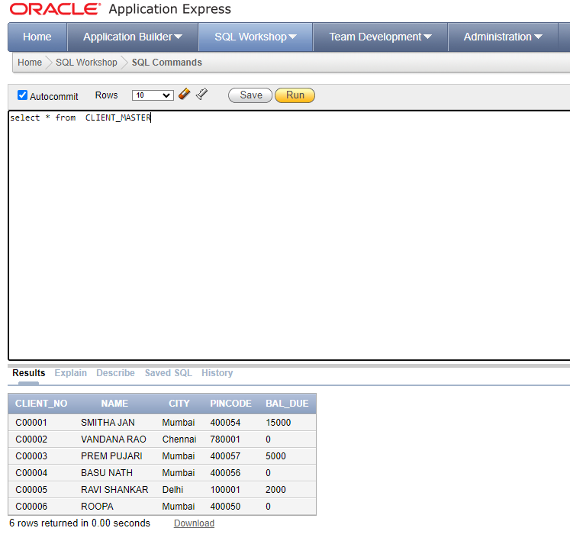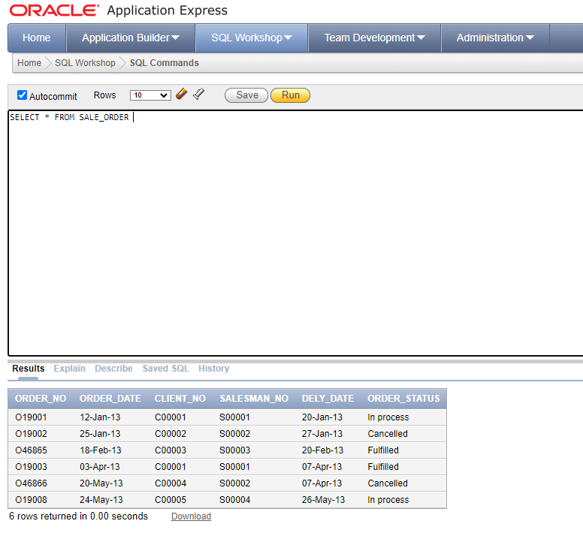

List all details from the client_master table for clients whose Bal_due = 0.

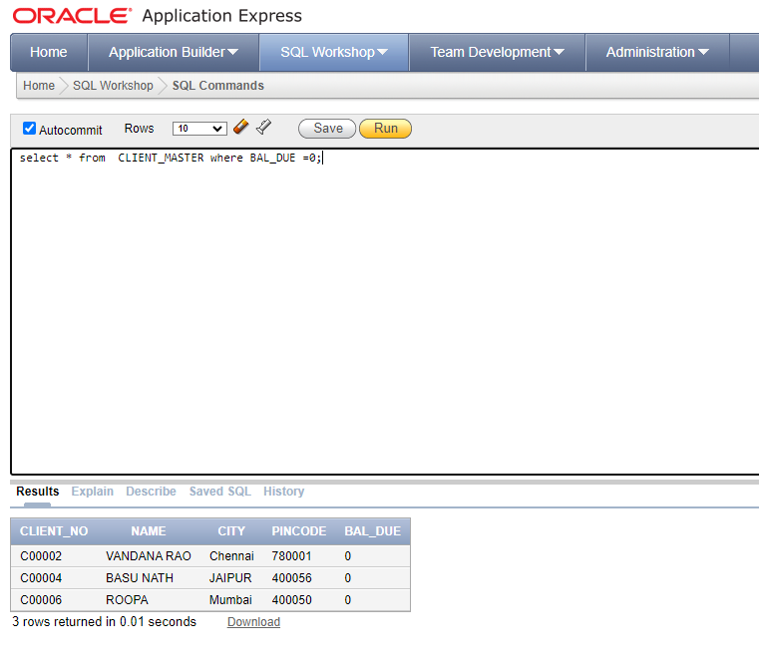

Update table client_master, Change city of Client_no C00004 to Jaipur.

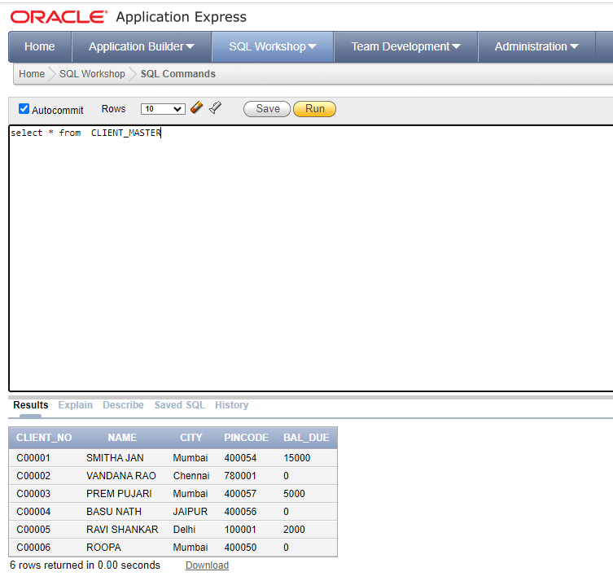

Retrieve records of clients residing in Mumbai.

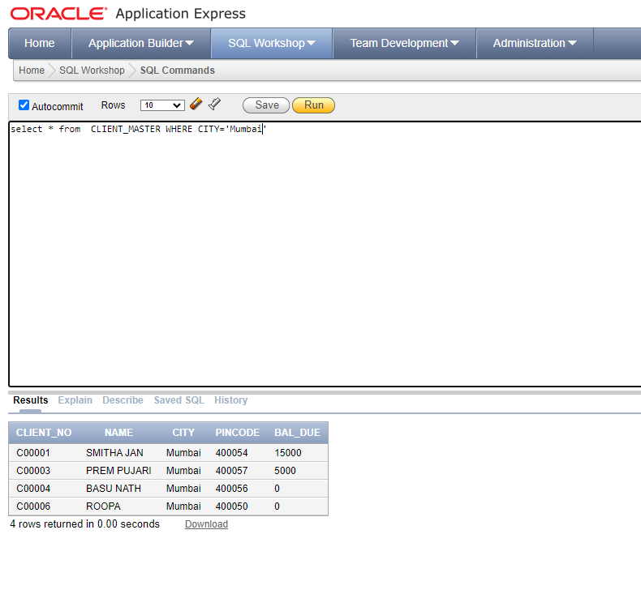

Find the name and address of customer who has placed Order_no 'O19003' and 'O19002' respectively.

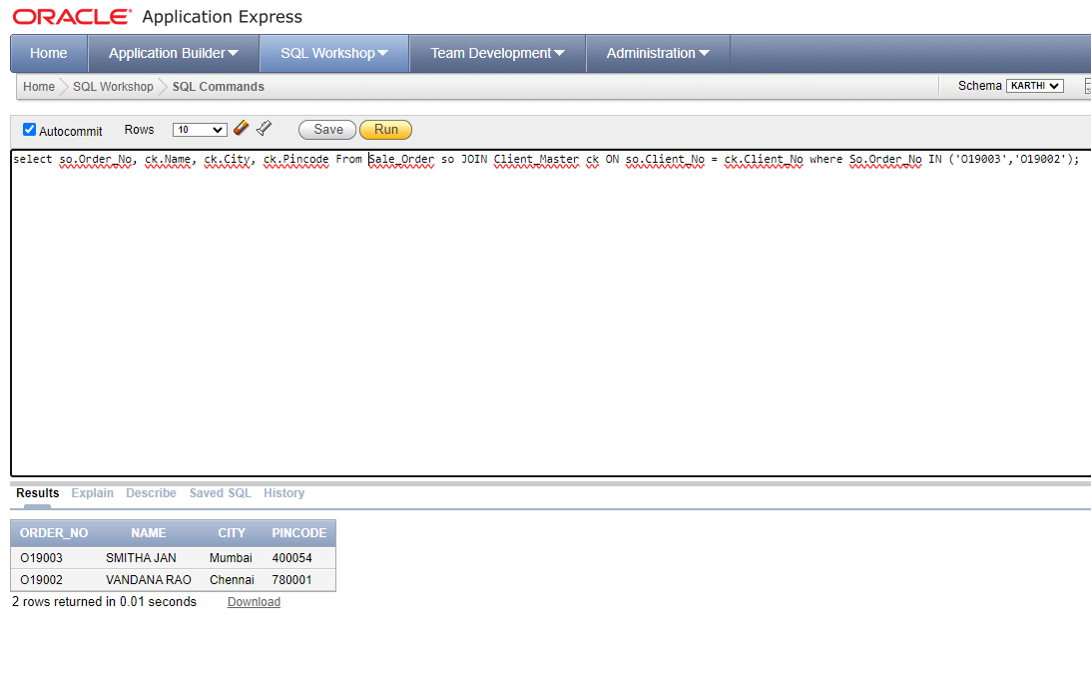

Construct English like sentence from the table client_master ({Customer name} live in the city of {city}).

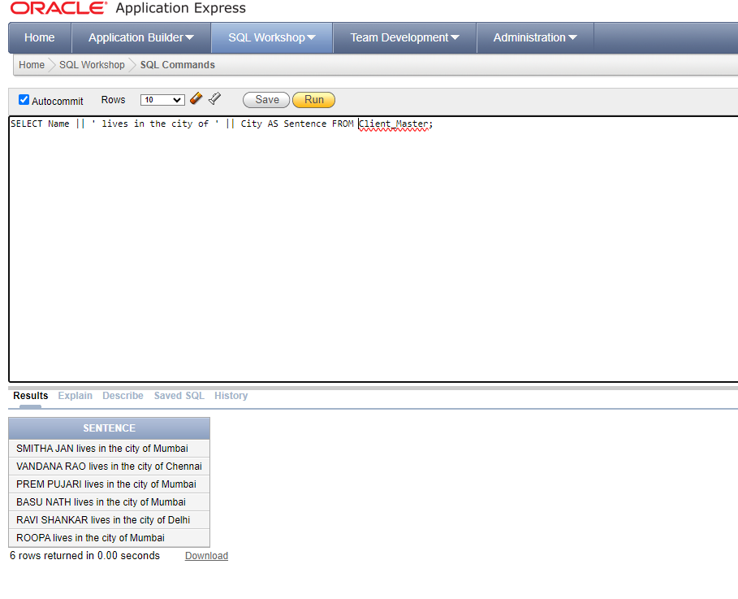

List the client_no, name, city and pincode of clients whose Order_status is "In process"

